4.
E-FORM
P.2, r.4, P.7, r.4,
Third Schedule, Part 1, Division 4, Item 17 FJ(G)R 2024

Notice to Contest

Applicable only to Divorce, Nullity, Judicial Separation and Presumption of Death and Divorce applications.

State the main case number: Enter main case number here. |  | Notes
Part A
1. | I am the:  ☐ Respondent  ☐ Co-Respondent  ☐ Named Person | If you file this Notice as a Named Person and do not agree to the application, you will be joined as a Co-Respondent in the application.
2. | I received the Originating Application on: Enter date here.
Dissolution of Marriage
3. | The Applicant has applied for [Select the applicable option].  ☐ I agree to the application.  ☐ I do not agree to the application.  For Respondent, proceed to question 4.  For Co-Respondent and Named Person, proceed to:  - Part B if you are acting in-person (i.e. do not have a lawyer representing you).  - Part C if you are represented by a lawyer. | The applicable options are: Divorce / Nullity / Judicial Separation / Presumption of Death and Divorce.  Selecting “I agree to the application” means you agree that the marriage is to be dissolved. This does not mean that you agree with the ancillary reliefs which is dealt with separately in paragraph 4.  If you also intend to file an application for dissolution of marriage or challenge the jurisdiction of the Singapore Court, select “I do not agree to the application”. You must file your own Cross-Application (or a summons to dispute jurisdiction if applicable) within the same timeframe for your Reply. Please refer to paragraph 3 of the Notice of Proceedings (General) (Form 71A).
Ancillary Reliefs
4. | I wish to be heard on the following matters:  ☐ Custody of, care and control of, access to the minor child(ren)  ☐ Division of the matrimonial assets  ☐ Maintenance for the wife  ☐ Maintenance for the incapacitated husband  ☐ Maintenance for the child(ren) of the marriage  ☐ Costs  ☐ Others:  Proceed to:  - Part B if you are acting in-person (i.e. do not have a lawyer representing you).  - Part C if you are represented by a lawyer. | The Court will deal with the following issues if the marriage is dissolved (i.e. the Interim Judgment is granted):  - arrangements for minor child(ren) of the marriage,  - division of matrimonial assets,  - maintenance for child(ren) and spouse.  These are called “ancillary reliefs”.
  Enter information here.
Part B (To be completed if you are acting in-person)
1. | I can receive correspondence at:  You must provide either a Singapore address or your email address. | This information will be completed for you based on your details in Section B in the Originating Application: Generic Sections (Form 53B).
 | Address (in Singapore) | Provide the address at which you can receive Court notices. P.O. Boxes are not acceptable.
  Enter address here.
Email
Enter email address here.

Contact Number(s)
You must provide at least one contact number.

Singapore mobile number
Enter mobile number here.

Singapore residential number
Enter residential number here.

☐ I do not have a Singapore contact number.
2. | Do you require interpretation for Court hearings? | Should you require the Court to provide a translator in one of these languages, please file a Request for Hearing Administrative Support prior to the Court event.  The applicable options are: Cantonese / Hakka / Hokkien / Teochew.
  ☐ No.
  ☐ Yes. State which language/dialect:
   | In ☐ Mandarin ☐ Malay ☐ Tamil
   | ☐ Chinese dialects: | Select a dialect
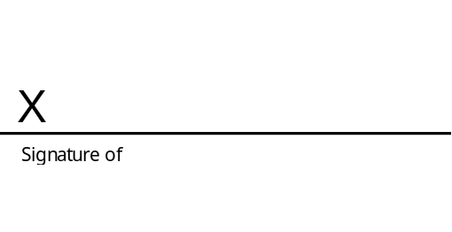
Name: Enter full name as per NRIC/Passport here.
NRIC/FIN/Passport number: Enter identification no. here.

Date:
Enter date here.

Part C (To be completed if you are represented by a lawyer)
☐ I am represented by a lawyer.  Complete the details below.  Name of lawyer and law firm  Lawyer’s address and email address  Lawyer’s Contact Number(s)  You must provide at least one contact number.  Mobile:  Direct line: |  | This information will be completed for you based on your details in Section B in the Originating Application: Generic Sections (Form 53B).
  Enter name of lawyer and law firm here.
  Enter lawyer’s address and email address here.
  Enter mobile number here.
  Enter number here.
Counsel for the Enter party type here.

Date:
Enter date here.

Part D: Return the completed Form
Please return the completed Form to:  Details of the other parties / other parties’ lawyers will be included in the Form. |  | If the other party is represented by a lawyer, you may opt to serve the document through eLitigation.

